

MODULE - CORE 04

DEMONSTRATE AN UNDERSTANDING OF LEGAL REQUIREMENTS AND COMPLETE LOG BOOKS
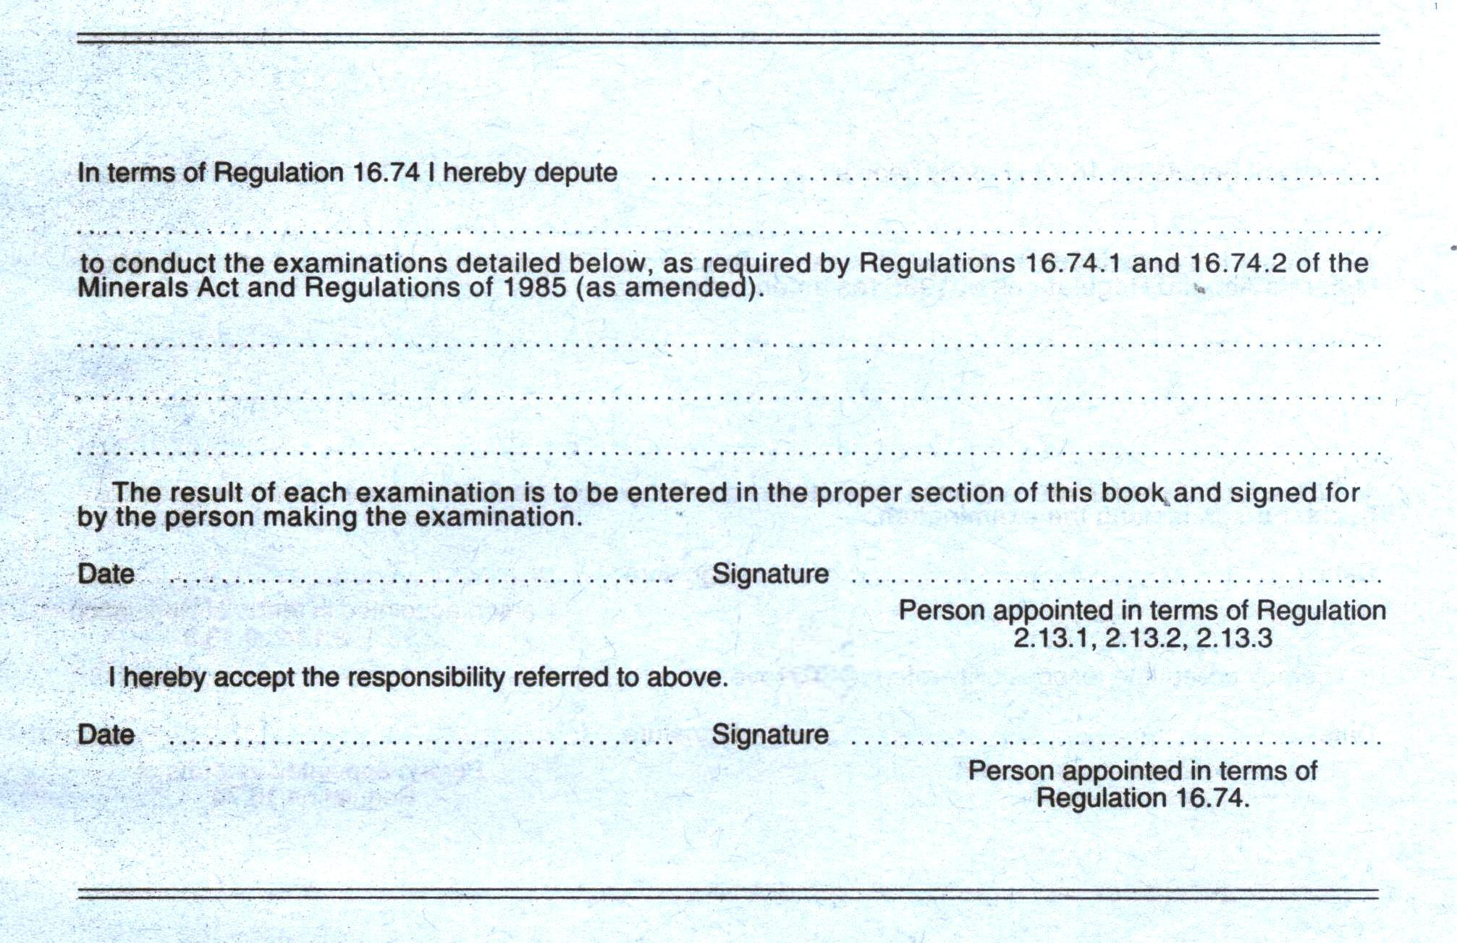

WINDER MAINTENANCE SKILLS
PROGRAM
CORE
01
CORE
02
CORE
03
CORE
04
CORE
05
CORE
11
WINDER MAINTENANCE
SKILLS PROGRAM
ELECTRICAL
WINDER MAINTENANCE
SKILLS PROGRAM
MECHANICAL

CONTENTS

The following elements are contained in this learning guide:

Topic Page
CONTENTS 3
SOURCE REFERENCES 4
OBJECTIVE 5
USING THIS LEARNING GUIDE 6
Introduction 8
Regulations applicable to the appointment of persons to examine winding equipment 12
Regulations applicable to the winding plant record and log books 14
Regulations applicable to the driver's log book 15
Regulations applicable to small winding plants 18
Regulations applicable to the elevator record book 20
Regulations applicable to the Humble Hook record book 22
Preface to the substation record book 26
Code of Practice of the substation record book 28
Requirements of the driver’s report 31
Requirements regarding the examination 33
Special instructions or warnings to the engine driver 34
Reporting of defects or dangerous practices 35
Requirements to complete the machinery record book 37
Requirements to complete the small hoist record book 41
Requirements to complete the elevator record book 43
Requirements to complete the substation record book 49
Requirements to complete the humble hook record book 53

SOURCE REFERENCES

- Mines Health and Safety Act
- Manufacturers and Suppliers Specifications
- In-company Standard Operating Procedures
- In-company documentation
- Operating drawings and schematic diagrams
www.safcec.org.za/SAFETY_REGULATIONS.HTM

OBJECTIVE
You will be learning towards the outcome “Demonstrate an understanding of Legal Requirements and complete log books”. Whilst learning towards the outcome you will be required to achieve the following specific outcomes:
- Describe the regulations applicable to record/ log books
- Describe the regulations applicable to the substation record book
- Complete the drivers log book
- Complete the machinery record book
- Complete the small hoist record book
- Complete the elevator record book
- Complete the substation record book
- Complete a Humble hook log sheet

During this process you must adhere to certain specified requirements as listed in the Module.

You will be assessed, when you are confident that you may achieve the outcomes as listed, to determine your competence as measured against specific outcomes. This assessment will be in line with accepted best practices regarding assessment.

USING THIS LEARNING GUIDE
Various methods are used in this learning guide to assist you, the learner, in carrying out the work as outlined in the Module. Brief outlines of these methods are detailed in this section.

Knowledge, Skills, Techniques (The What, How, When, How well)
Specific outcome requirements are grouped to give information and details on the knowledge, skills and techniques applied in attaining specific assessment criterion standards. In other words, the what, how, when, how well to do a certain task. Information is supplied that will indicate how well the task must be performed to be measured as correct, as well as, If required, information covering any special techniques that may be utilised to perform the task successfully.

Purpose, (Why)
Health and Safety (Hazards, Risks, Consequences and Prevention)
Certain symbols are used to provide information that will indicate the consequences if the task is not performed as described, as well as expanding and explaining the “what” and the “how” of the task being performed.

The following symbols and sequence are used in this learning guide:

 | This Symbol Indicates Severe Consequences May Result.  This symbol indicates to the learner and the trainer / facilitator that the topic being discussed has inherent dangers, hazards and risks. Ignoring these issues may result in personal injuries, damage to equipment and decreased productivity.  In the learning guide, this sign indicates that the accompanying information must be dealt with in sufficient detail, so that clear understanding of the topic being dealt with is ensured.
 | This Symbol Indicates Important Health And Safety Information.  This symbol indicates information for the learner and the trainer / facilitator to take note of. The information will normally be of a health and safety nature. Although the information may not be highly critical, it is important that an understanding of the information is established in order to allow correct and complete learning.
☞ | This Symbol Indicates Learner Or Trainer / Facilitator Action.  This symbol indicates to the learner and the trainer / facilitator that some action to further the understanding of the subject being dealt with should be performed.
 | This Symbol Indicates Useful Information Covering The Subject Being Dealt With.  This symbol normally covers background information that will facilitate the learning process. This is especially so for the more “complex” issues.
LARGE BOLD TEXT | Large Bold Text Indicates The Portions Of The Training Material That Must Be Dealt With.  Large bold text indicates the critical learning issues and will be essential to achieve competency in terms of the Module.

Introduction

One of your responsibilities as a winder artisan is to record and sign for conditions found during examinations and inspections of winding plant, substation switchgear, etc, in their respective record or log books. It is required by law and mine standards, that a true reflection of the condition of the plant and its components or equipment is recorded or logged.

If any adverse conditions found during examinations or inspections are properly recorded and brought to the attention of management, they are in the position to take corrective measures and steps to have it rectified. Examination or inspection of electrical equipment plays a major role in the mining industry and on your part it is a big responsibility. The reason is that person’s lives depend on the safe operation of plant or equipment.

In some of the manuals in this training program we will be dealing with the examination and inspection of winding plant electrical equipment and components. It is imperative at this stage that you must be familiar with the requirements of all the respective record / log books for your work situation and be competent in the completion thereof.

In this manual we will be dealing with the following record / log books:
- Drivers' Log Book
- Machinery Record Book
- Small Hoist Record Book
- Elevator Record Book
- Substation Record Book
- Humble Hook Record Book

Drivers' Log Book
The Drivers' Log Book is the Drivers’ responsibility and acts as a daily report on the condition of the winding plant to Management.

The driver will record and report any adverse condition of the winding plant as found by him during his period of operation.

The Drivers' Log Book is recorded in duplicate and the original log sheet is removed and forwarded to the responsible Section Engineer daily to scrutinize and sign, and if required, take the necessary steps to ensure that any adverse conditions reported in the Log book are immediately attended to.

Certain conditions regarding the completion of the Drivers' Log Book are applicable to you with respect to daily duties as required by the regulations we have dealt with is section "1.6 Drivers' Log Book" of this manual. In this module we will cover all the aspects of the completion of the Drivers Log Book as far as you are concerned.

Machinery Record Book
Being acquainted with the legalities applicable to Machinery Record Books, you should now be in a position to appreciate the fact why it is necessary to keep records of a true report of every examination or inspection in accordance with regulation 16.74.1.

Recalling the regulation you will remember that the safety of persons depends upon the proper working of the safety devices and equipment which is your duty to inspect or examine.

In the Mining Industry some artisans are lax, and find it cumbersome to record and sign the Record Books timeously and require to be reminded by their Engineers to do so. These acts or omission to record and sign the Record Books are a contravention of the regulations as such, and they shall be deemed to be guilty of such contravention (regulation 3.11) and duly charged to appear before the Inspector of Machinery and will have to suffer the consequences.

Small Hoist Record Book
The minimum power of winding plant for which a permit is required is 100 kW; less than this does not require a permit provided that its use complies with regulations. This is explained more in the relevant section of this module.

Elevator Record Book
Each elevator is required to have its own record book in which a true record is kept of any maintenance or inspection performed.

Sub-station Record Book
A Standard Code of Practice is enforced for certain record-keeping activities. What is meant by a Standard Code of Practice? A Code of Practice defines a standard of good practice which shall be enforced by all Engineers in terms of their letters of appointment. It is NOT merely a set of recommendations.

This Code shall take precedence over the provisions of any other Standard Practice or instructions issued on the mines, insofar as Electrical and mechanical Equipment is concerned. However the issue of and compliance with this Code does not confer immunity from, nor should it be taken to countermand, any provision of the Mines and Works Act (Act. no. 27 of 1956, as amended) or the regulations forming part thereof.

Further more, the scope of this Code is that it is intended for distribution to all engineering personnel who, in the course of their official duties, are responsible for the proper functioning of electrical and mechanical equipment and the safety of persons using it. The Code defines good practice for the selection, installation, operation, and repair of electrical and mechanical equipment, and all persons involved are required to adhere strictly to it. The Code recognises and requires that regular routine inspection and maintenance be done in accordance with the Planned Preventive Maintenance Scheme, since such inspection and maintenance is an essential part of good practice and vital to the attainment of a high standard of safety.

Humble Hook Record Book
The reason for the Humble Hook record book is that, at all times when changing a Humble Hook in a compartment its serial number, size and drawing number should be recorded. Every Humble Hook should have its own record sheet. Each Humble Hook is supplied with the manufacturer’s certificate. This certificate must be kept in the Engineers office.

The following details must be recorded:
- Date when installed or removed.
- Location.
- Compartment.
- Total of months worked.

If the Humble Hook is removed and maintained the following should be recorded:
- Part Description.
- Reason for replacement.
- Date.

You need to record the dates of the NDT (Non Destructive Tests) done.

ASSESSMENT CRITERION 1.1

Regulations applicable to the appointment of persons to examine winding equipment

There are certain regulations which specifically apply to Winding Plant Record and Log Books. In this module we will discuss these regulations so that you will realise their importance and also be able to correctly interpret and recall the regulations from memory.

Firstly let us have a look at the appointment of persons to examine winding equipment, as it is most important and applies to all the winding plant record and log books. You must be appointed in writing before you are allowed to work on winding equipment.

REGULATIONS APPLICABLE TO APPOINTMENT OF PERSONS TO EXAMINE WINDING EQUIPMENT
16.74 The person appointed in terms of regulation 2.13.1, 2.13.2 or 2.13.3 shall appoint in writing some competent scheduled person or persons whose duty it shall be to examine carefully


16.74.1 at least once in each day the winding ropes, the balance ropes or tail ropes, the connection of the winding ropes to the drums, the connection referred to in regulation 16.18, the conveyance and the main members by which they are suspended and any safety catches attached thereto, the pulley wheels and sheaves, the brakes, the depth indicators, the safety devices and all external parts of the winding equipment upon the proper working of which the safety of persons depends: Provided that these examinations will not be necessary on any day mentioned in section 9(1) of the Act, if the winding plant makes less than 50 trips during any such day, and


16.74.2 At least once in each week the signalling arrangements and safety devices used in connection therewith.


EXPLANATION OF REGULATIONS
Regulation 16.74: The persons appointed in terms of regulation 2.13.1, 2.13.2 or 2.13.3 are as follows:

2.13.1 The Resident Engineer
2.13.2 Not applicable on our complex, due to the requirements of the regulation.
2.13.3 Subordinate Engineers to assist the Resident Engineer such as Assistant Resident Engineer, Electrical Engineer and Sectional Engineers.

Therefore it will be required that you be appointed in writing by one of the above mentioned Engineers, usually the Engineer directly responsible for the winder, to examine carefully

- At least once in each day the safety devices and all external electrical parts of the winding equipment upon the proper working of which the safety of persons depends: provided that these examinations will not be necessary on say specific holidays, etc. if the winding plant makes less than fifty (50) trips during any such day, and

- At least once in each calendar week the signalling arrangements and safety devices used in connection therewith.

ASSESSMENT CRITERION 1.2

Regulations applicable to the winding plant record and log books

The Machinery Record Book is the record kept of any activity on the winding plant.

REGULATIONS APPLICABLE TO WINDING PLANT RECORD BOOKS
16.78 The manager shall provide for each winding plant a book termed the Machinery Record Book in which shall be entered:
16.78.1 the name of each person appointed under regulation 16.74 to perform the duties called for in the said regulation together with the particulars of the duties of each such person; and
16.78.2 A true report of every examination referred to in regulation 16.74, 16.75 and 16.76. These reports shall be recorded and signed without delay by the persons making such examination. The reports made by the persons appointed in terms of regulation 16.74 shall be scrutinised and countersigned by the person appointed in regulation 2.13.1, 2.13.2 or 2.13.3 at least once in each week.

EXPLANATION OF REGULATIONS
Regulation 16.78:
- For every winding engine in your section of responsibility you will find a Machinery Record Book, which is usually kept in the responsible Engineer's office or in the engine room.

- Your responsible Engineer must appoint you in writing in each respective winding engine's Machinery Record Book in your section of responsibility, where it is required that you sign it to acknowledge the appointment under regulation 16.74.

- A true report of the examinations of the equipment referred to in regulation 16.74.1 shall be recorded and signed without delay by you in the respective winding plant's Machinery Record Book.

ASSESSMENT CRITERION 1.3

Regulations applicable to the driver's log book

MINES AND WORKS ACT AND REGULATIONS APPLICABLE TO DRIVERS' LOG BOOK

16.81 The manager shall provide in respect of each winding engine, a book to be termed the Drivers' Log Book, which shall be kept in the winding engine room and entries in which shall be recorded in duplicate:

16.81.4 Any warning given in terms of regulation 16.55 and the time such warning was given.

16.82 The entries in the Drivers' Log Book shall be scrutinised and countersigned daily by the person appointed to carry out the duties specified in regulation 16.74. The duplicate shall be scrutinised and countersigned within 24 hours by the person appointed in terms of regulation 2.13.1, 2.13.2 or 2.13.3, and shall be retained by him for at least 30 days.

EXPLANATION OF REGULATIONS
- This means that in every driver's cabin of all the winders in your section of responsibility you will find a book termed the Drivers' Log Book.

- Any warning you may give the driver in terms of regulation 16.55 must be recorded in the log book, and the time such warning was given (regulation 16.55 will be discussed in another chapter).

- In the case of regulation 16.82, you are required to scrutinize the entries made by the drivers regarding the condition of the winder and countersign their entries. If any entries may have been made concerning winding plant equipment which is your responsibility, you must investigate and carry out the necessary repairs, or if unable to do so, report the matter to your responsible Engineer.

DRIVER TO BE SPECIALLY WARNED
16.55 The person in immediate charge of any repairs or examination in a winding compartment of a shaft or a headgear or in immediate charge of any work in connection with maintenance of equipment in a winding compartment of a shaft or a headgear shall warn the driver of the winding engine operating the conveyance in such compartment that such repairs, examination or work are about to be undertaken and where practicable shall enter forthwith, in the presence of the driver on duty at the time, such warning in the driver's log book provided in terms of regulation 16.81.

Such entry shall be countersigned by the driver and by any driver relieving him. Where it is not practical for the person in charge of such repairs, examination or work to enter such warning, the entry shall be made by the driver on duty. Except where provisions of regulations 16.53.2 and 16.54.1 are complied with, the driver of every other winding engine operating conveyances in the shaft or headgear shall be warned in a similar manner. The entry shall be cancelled by the person in immediate charge of such repairs, examination or work on completion thereof.

EXPLANATION OF REGULATIONS
- Whenever you are in charge and conduct examinations or repairs to winding plant and equipment, in the engine room, on the bank, in the shaft or the headgear, you must warn the driver and enter what you are going to do, as well as enter the time you start. This entry must be done in the presence of the driver on duty at the time. Your entry must be countersigned by the driver in your presence and by any driver relieving him.

- Where it is not practical for you when in charge of examination, repairs or other work in connection with the winder, to enter such warning in the Drivers' Log Book, you must warn the driver by telephone and he will make the entry in the Log Book on your behalf. You must "clear" the entry when you have completed the work.

- Whilst you are conducting an examination, repairs or other work in a shaft or headgear, and you are not adequately protected from the conveyances and other winding equipment used in such winding operations as well as from falling stones or falling material. The drivers of every other winding engine operating in the same shaft or headgear must be warned in a similar manner, when you have obtained permission from the Engineer to stop winding operations.

- On completion of your examination, repairs or other work carried out you must "clear" the Driver's Log Book or books and sign it. Driver to countersign in your presence.

- Before and after your examination of the winder, you must enter the time at the start and end and sign the log book.

ASSESSMENT CRITERION 1.4

Regulations applicable to small winding plants

MINES AND WORKS ACT AND REGULATIONS APPLICABLE TO SMALL WINDING PLANTS (Small Hoist Record Book)


Permit not required.
Note: On Impala Platinum all small hoists are regarded as Licensed Winders and are to be treated as such.

16.94 The permit mentioned in regulation 16.2 shall not be required for a winding plant that is driven by an engine or motor developing not more than 250 kilowatt (kW). Provided that such winding plant:

16.94.1 Is not used for the raising or lowering of persons other than persons engaged in repairing or examining a shaft or winze;

16.95 the winding plant referred to in regulation 16.94 shall not be subject to the provisions of regulations 16.5.1, 16.5.2, 16.7, 16.9 to 16.15 inclusive, 16.18, 16.19, 16.24, to 16.29 inclusive, and 16.81: Provided that the Manager or subordinate manager appointed in terms of regulation 2.6.1 shall appoint in writing some competent scheduled person or persons to carry out the duties and examinations prescribed in regulation 16.74 and provided further that the person appointed in terms of regulation 2.13.1, 2.13.2 or 2.13.3 shall appoint in writing some competent schedule person or persons whose duty it shall be to examine carefully at least once in each week the items specified in regulations 16.74.1. Notwithstanding the provisions of regulations 16.78 and 16.97, a Small Hoist Record Book or card index system may be provided in place of the Machinery Record Book.
EXPLANATION OF REGULATIONS
- Any winding plant that is driven by an engine or motor developing not more than 100 Kilowatt does not require to be licensed by the Inspector of Machinery, provided that such winding plant:

- Is not used to convey persons other than persons repairing or examining a shaft or winze.

- Regulation 16.95 has the similar requirements as regulation 16.78 (Machinery Record Book). It is in this instance also the responsibility of your responsible engineer to appoint you in terms of regulation 16.74 to carry out your duties as laid down in regulation 16.74.1.

- In this case it is only required that you carefully examine the items as prescribed in regulation 16.74.1 not less than once a week and not on a daily basis as is required with licensed winding plant, and record and sign the Small Hoist Record Book.

ASSESSMENT CRITERION 1.5

Regulations applicable to the elevator record book

MINES AND WORKS ACT AND REGULATIONS APPLICABLE TO ELEVATOR RECORD BOOK
17.3.4. The manager shall provide for each elevator an Elevator Record Book in which shall be entered:

- The name or names of the competent person or persons appointed to carry out the examinations prescribed in regulations 17.5.1 and 17.5.2,
- A true report of the result of every examination prescribed in regulations 17.5.1 and 17.5.2 and details of any repairs or alterations made. The report shall be signed by the person who carried out the inspection or affected the repairs or alterations.

EXPLANATION OF REGULATION
- You will find an Elevator Record Book for each elevator in your section of responsibility, usually kept in the responsible Engineer's office.

- Where is it the duty of the responsible Engineer to appoint you in writing to carry out your weekly examinations; and

- Where it is your responsibility to record a true report of every examination you may carry out, including details of all repairs or alterations made by you. You shall also sign for every report entered by you in the Elevator Record Book.

INSPECTION OF ELEVATORS
17.5.1 The manager or person appointed in terms of regulation 2.13.1, 2.13.2 or 2.13.3, shall depute some competent person or persons, who shall examine carefully at least once in each week the hatchway, the guides, the ropes and their connections, the engine or motor, the drums and sheaves and all safety appliances.
17.5.3 If as a result of examination, any weakness or defect is found whereby the safety of any person is or may be endangered, the defect shall be reported in writing without delay to the manager or person appointed in terms of regulation 2.13.1, 2.13.2 or 2.13.3 and no person shall be conveyed until the defect has been rectified.

EXPLANATION OF REGULATIONS
- In this case it shall by your responsibility to carefully examine at least once in each week, the motor and all electrical safety appliances of the elevators in your section of responsibility.

- If during your examination of the equipment prescribed in regulation 17.5.1 you find any weakness or defect of the equipment, whereby the safety of any person is endangered, you must immediately stop the elevator from operating and report the matter to your responsible Engineer and not allow any person to travel in the elevator until such weakness or defect has been rectified or repaired.

ASSESSMENT CRITERION 1.6

Regulations applicable to the Humble Hook record book

MINES AND WORKS ACT AND REGULATIONS APPLICABLE TO HUMBLE HOOK RECORD BOOK

16.57 Where winding is carried on in a shaft or winze there shall be fitted above the bank spring keps or jack catches or some other effective contrivance to support any conveyance detached from the winding rope as a result of an overwind.

  - For a winding system in a vertical shaft or winze where the end of the winding rope is fastened to the drum of the winding engine, there shall be fitted detaching hooks to detach from the winding rope any conveyance overwound in the headgear and to support it. Such detaching hooks shall be additional to the devices required in terms of regulation 16.57: Provided that detaching hooks need not be fitted to the ropes of any winding plant used in a vertical shaft or winze in the course of being sunk.

16.16 No rope, bar, link, chain or other connection shall be used for winding purposes unless it is of good quality and manufacture, free from any visible defect and of adequate calculated strength.

16.17 The connection between -
(a) Any winding rope and the cage, skip, bucket, kibble, other means of conveyance or counterpoise,
(b) Any balance rope or tail rope and the conveyance or counterpoise, and
(c) Any connecting rope and the conveyance and any trailer or other attached conveyance,

Shall be such that no accidental disconnection can take place.

16.18 At intervals of not more than 6 months the connections between -
(a) Any winding rope and the conveyance or counterpoise,
(b) The conveyance and any trailer or other attached conveyance, and
(c) Any balance rope or tail rope and the conveyance or counterpoise,

Shall be annealed or given other proper heat treatment or shall be discarded and replaced. With connections of a class of steel approved by the Chief Inspector, the interval for heat treatment may be extended with the written permission of the Chief Inspector.

16.19 A proper record shall be kept of the heat treatment and working life of the connections referred to in regulation 16.18 and an engineer shall add to the record the report on the method procedure followed in such treatment and his comments on the results. All such connections and their component parts shall be marked clearly for the purpose of identification.

EXPLANATION OF REGULATIONS

- In this case it shall by your responsibility to carefully examine at least once in each day, the humble hooks in your section of responsibility.
- The Humble hook is to be changed every 6 months and all the relevant information is to be recorded.
- The humble hook is to be thoroughly inspected, cleaned and lubricated before being put back into service.
You have completed this theory section of the Module. If you feel confident you are now at liberty to write the theory assessment. Make an appointment with the training department and go and write the test. Remember you need to obtain 100% to pass this Specific Outcome.
Good luck and don’t worry, the trainers are there to help you. Below is a guide line of what is required.
Assessment criteria | Evidence required  Expected answer or performance required
- The regulations applicable to the appointment of persons to examine winding equipment is explained | Did the candidate satisfactorily explain the regulations applicable to the appointment of persons to examine winding equipment?  The explanation must include regulation 16.74, parts 16.74.1 and 16.74.2.  Critical cross-field outcome of demonstrate an understanding of the world as a set of related systems by recognising that problem-solving contexts do not exist in isolation.  Being found competent in this AC demonstrates the ability of the candidate to understand the legislated requirements of examining winding equipment.
- The regulations applicable to winding plant record and log books are explained | Did the candidate explain the regulations applicable to winding plant record and log book?  The explanation must include the applicable regulations for winding plant record and log books (regulation 16.78, 16.78.1 and 16.78.2).
- The regulations applicable to the Driver’s log book are explained | Did the candidate explain the regulations applicable to the Driver’s log book?  The explanation must include regulations 16.81, 16.81.4 and 16.82 for Driver’s log books.
- The regulations applicable to small winding plant are explained | Did the candidate explain the regulations applicable to small winding plant?  The explanation of regulations for small hoists must include regulations 16.94, 16.94.1 and 16.95 for small winding plant.
- The regulations applicable to elevator record books are explained | Did the candidate explain the regulations applicable to elevator record books?  The explanation of regulations must address 17.3.4 for elevator record books.

ASSESSMENT CRITERION 2.1 (Electrical Only)

Preface to the substation record book

THIS BOOK IS TO BE USED IN ACCORDANCE WITH THE INSTRUCTIONS GIVEN BELOW. UNDER NO CIRCUMSTANCES IS IT TO BE REMOVED, DEFACED OR USED FOR ANY OTHER PURPOSE WHATSOEVER.

The following points should all be adhered to:
- All switching operations on high voltage systems may only be carried out by a skilled person in the presence of another competent person.

- In the context of these instructions:
A "skilled person" shall be taken to mean an Engineer, Electrical superintendent, Electrical Foreman or an employee who is a qualified Electrician, and has been sufficiently instructed in the particular work that he is called upon to do and to understand the dangers attached to electrical work.

A competent person shall be taken to mean any person having the knowledge, training, experience and qualifications specific to the work or task being performed.

- The recording of all switching operations, or any material adjustment or modification of any kind as well as the recording of any maintenance to H.V. equipment and testing of protective devices, must be made in this logbook and noted, dated and signed by the person responsible.

- This log book must remain in the substation at all times and should be initialled by the Surface Foreman electrician a minimum of once every 30 days.

- Whenever an H.V. circuit breaker trips, the skilled person responsible for reclosing that circuit breaker should record in the log book what protective relays (if any) "flagged" and on what panel they are situated.

NOTE: On the standard 3 tier CDG36 relay used for over current and earth fault protection the flag that dropped should be identified by using the words "top", "middle" and "bottom" to prevent misunderstandings).


FIRE EXTINGUISHERS

- Every substation is to contain 2 or 4 9kg Dry powder type, and a 15kg CO₂ fire extinguisher, respectively, depending on the size of the substation.
- These extinguishers are to be situated inside, but immediately adjacent to each entrance door.
- Where possible the extinguishers should be mounted on the inside of the door, so that an extinguisher is immediately visible and accessible on opening the door.
- The Surface Foreman Electrician should arrange that the Service Department supply, and check and maintain these extinguishers at periods of no longer than 3 months.
- In addition the section electrician should inspect monthly to confirm that the extinguishers are in place and the seals are not broken. The result of his inspection should be recorded in this log book and the Surface Foreman should be notified if found not to be in order.

ASSESSMENT CRITERION 2.2 (Electrical Only)

Code of Practice of the substation record book

The Substation Record Book
The Substation Record Book is only to be used in accordance with the instructions of the Preface to Substation Record Books.

You must never remove, or allow the Substation Record Book, to be removed from the substation.

It is the duty of the Surface Foreman Electrician to initial the Record Book at least once every 30 days.

Do not deface, tear out pages, or use the Substation Record Book for any other purpose whatsoever, other than what it is intended for.

Recording of Substation Record Book
- The following must be recorded in the Substation Record Book, dated and signed by the person responsible:

(1) All switching operations.
(2) Any material adjustment of any kind.
(3) Maintenance to H.V. equipment.
(4) Testing of protective devices. .
(5) Protection relay settings - (as changed by Elec. Eng. only).

- Whenever an H.V. circuit breaker trips, you as a skilled person responsible for reclosing that circuit breaker, must record in the Record Book what protective relays (if any) "flagged" and on what panel they are situated.

NOTE: On the standard 3 tier CDG 36 relay used for over current and earth fault protection, you must identify the flag that dropped by using the word "top", "middle" and "bottom" so as to prevent any misunderstandings.

- You as the Section Electrician must inspect the substation fire extinguishers on a monthly basis to confirm that the extinguishers are in place and the seals are not broken. It is your duty according to the instructions of the code, to record the results of your inspection in the Record Book and if found not to be in order, immediately notify the Surface Foreman Electrician.

You have completed this theory section of the Module. If you feel confident you are now at liberty to write the theory assessment. Make an appointment with the training department and go and write the test. Remember you need to obtain 100% to pass this Specific Outcome.
Good luck and don’t worry, the trainers are there to help you. Below is a guide line of what is required.
Assessment criteria | Evidence required  Expected answer or performance required
2.1 The preface to the substation record book is explained | Did the candidate explain the preface to the substation record book?  The explanation must show understanding of the preface to the substation record book  Critical cross-field outcome of demonstrate an understanding of the world as a set of related systems by recognising that problem-solving contexts do not exist in isolation.  Being found competent in this AC demonstrates the ability of the candidate to understand the legislated requirements of the Substation record book
- The code of practice of the substation record book is explained. | Did the candidate explain the code of practice for the substation record book?  The explanation must include an understanding of the code of practice covering substation record books.

ASSESSMENT CRITERION 3.1

Requirements of the driver’s report

This copy of a sheet taken from a Drivers' Log Book should be familiar to you. Take some time to ensure you know how to fill it in correctly and completely.

How to fill in the driver’s Log Book:
There are 5 areas to completing the Driver’s Log Book – these areas are described over the next few pages.

Your first duty on a daily basis is to go to the respective winders driver's cabins in your section, and scrutinize the Log Books, paying special attention to the sections "Report on the Condition of the Winding Engine" and "Special Remarks by Drivers".

If any adverse conditions have been recorded (which is your responsibility according to the regulation 16.74.1) it is your responsibility to immediately investigate and effect repairs and if not possible, stop the winder and immediately notify the responsible Engineer.

The following notes indicate, by number, where various bits of information should be recorded on the Driver’s Log Book sheets.

NOTE: 1) Where the drivers enter their reports.
2) Artisan Daily Hoist Examination.
3) Artisan Working on Hoist.
4) Special Instructions or Warning to Winding Engine Driver.
5) Report any Defect or Dangerous Practices.

Name of shaft ………………………………… Compartment ……………………..……… Date …………………….…
DAILY REPORT OF DRIVER |  |  |  | DAY SHIFT |  |  | AFTERNOON SHIFT |  |  |  | NIGHT SHIFT
TIME & DURATION OF SHIFT
Report on the condition of the:
Winding engine |  | 1
Brakes |  | 1
Clutches |  | 1
Reversing gear |  | 1
Depth indicator |  | 1
All other fittings |  | 1
Safety Devices etc |  | 1
Signalling arrangements |  | 1
Faulty signals received |  | 1
SIGNATURE OF DRIVER |  | 1
 | TIME |  | SIGNATURE |  | DRIVER’S SIGNATURE |  |  | TIME CLEAR | SIGNATURE |  |  | DRIVER’S SIGNATURE
Fitter Skip/ Cage Exam | 2
B/Maker Skip/ Cage Exam | 2
Rigger Rope Exam | 2
Fitter Daily Hoist Exam | 2
Elec. Daily Hoist Exam | 2
Elec. Working on Hoist | 3
Fitter Working on Hoist | 3
Engineer Working on Hoist
Monthly Rope Exam
Shaft Examination
Special Instructions or Warnings to Engine Driver | 4
Special Remarks by Drivers
REPORT ANY DEFECTS OR DANGEROUS PRACTICES
REPORT ANY DEFECTS OR DANGEROUS PRACTICES | 5
REPORT ANY DEFECTS OR DANGEROUS PRACTICES | ARE YOU FULLY AWARE OF THE REQUIREMENTS OF REG. 16.74 & 16.74.1?

ASSESSMENT CRITERION 3.2

Requirements regarding the examination

Refer to the blank sheet of the Drivers' Log Book and on the bottom section you will see the question. "Are you fully aware of the requirements of reg. 16.74 and 16.74.1"?

Recalling the regulations from memory you will find that in regulation 16.74 you have to be appointed by your Sectional Engineer in writing to carry out your duties according to regulation 16.74.1, which in your case is to examine at least once in each day, the safety devices and all external parts of the winding equipment upon the proper working of which the safety of persons depends.

- STEP ONE:
Before you start your examination as required in regulation 16.74.1, it is required that you enter the time and your signature in the appropriate space in the Log Book (See no. 2 on copy sheet).

- STEP TWO:
Ensure that you tell the driver that you are about to start your examination and have him countersign in your presence to acknowledge your entry.

- STEP THREE:
You may then proceed to carry out your examination as required by law.

- STEP FOUR:
On completion of your examination, enter the time in the "TIME CLEAR" section of the log book plus your signature to indicate that you have completed your examination. Have the driver countersign in your presence to acknowledge what you have "cleared" the log book and he may carry on with his duties.

WORKING ON HOIST
Whenever you are required to work on the hoist, i.e. Weekly/Monthly/ Yearly examination or if any other work is required, the same procedure as explain previously must be followed. The entries must be made in the appropriate space (See no. 3 on blank sheet).

ASSESSMENT CRITERION 3.3

Special instructions or warnings to the engine driver

This space (see no. 4 on blank sheet) is provided on the log sheet, where special instructions or warnings to the driver have to be entered.

If for instance winder ropes back ends are cut and you have to bridge out certain sections of the safety circuit, then this must be entered in the log book, signed and the driver on duty to countersign in your presence to acknowledge your entry. When the task is completed and the bridges removed, you must enter this in the log book, sign and the driver to countersign.

When Bottom guide rollers on a conveyance need to be changed, a platform must be installed over the shaft and the winding engine driver must react with extreme caution, this action is considered a special instruction and must be written into the drivers log book and counter signed.

ASSESSMENT CRITERION 3.4

Reporting of defects or dangerous practices

(See no. 5 on blank sheet). If during your examinations or inspections of the winding plant you detect any adverse conditions or defect, according to reg. 16.77 you must immediately stop the -winder. Enter the defect or adverse condition in the space provided, and that the winder must not be used, sign and have the driver on duty countersign in your presence.

Immediately notify the responsible Engineer who will decide what remedial action to take. Do not "clear" the Drivers' Log Book until you have been informed to do so by the responsible Engineer after the defect or adverse condition has been repaired, or on his instruction that the driver may carry on with his duties.
You have completed this theory section of the Module. If you feel confident you are now at liberty to write the theory assessment. Make an appointment with the training department and go and write the test. Remember you need to obtain 100% to pass this Specific Outcome.
Good luck and don’t worry, the trainers are there to help you. Below is a guide line of what is required.
Assessment criteria | Evidence required  Expected answer or performance required
3.1 The requirements of the Driver’s report is explained | Did the candidate explain the requirements of the Driver’s report?  The explanation must include an overview of the different sections of the report that must be completed (by various people).  Critical cross-field outcome of demonstrate an understanding of the world as a set of related systems by recognising that problem-solving contexts do not exist in isolation.  Being found competent in this AC demonstrates the ability of the candidate to understand the requirements of the Driver’s log book.
3.2 The requirements regarding the examination are explained | Did the candidate explain the requirements regarding the examination of winding equipment?  The explanation must cover the preparation for examination and completion of the documentation afterwards.
3.3 The special instructions or warnings to the engine driver are explained | Did the candidate explain special instructions or warnings that may be given to the driver?  The explanation must include an understanding of the types if instructions or warnings that should be noted separately in the Driver’s log book.
3.4 The reporting of defects or dangerous practices are explained | Did the candidate explain reporting of defects or dangerous practices?  The explanation must include an understanding of what constitutes a defect or dangerous practice.

ASSESSMENT CRITERION 4.1

Requirements to complete the machinery record book

The Machinery Record Books will usually be found in the responsible Section Engineer's office or in the engine room.

On the following two pages you will find:
- A copy of the sheet in the Machinery Record Book where you will be appointed by the responsible Section Engineer.
- A copy of the report sheet where a true record of the results of examinations must be recorded.

On the first sheet you will be required to be appointed by your Section Engineer, who will enter your name and have you sign to indicate that you acknowledge the appointment on the specific date entered.

Once you have signed the appointment you will be held responsible to carry out your duties according to regulation 16.74.1.

Therefore make sure that you are duly appointed in all the Machinery Record Books for the winding engines in your section as well as for other winding engines if and when you are relieving on another section or working on a double section.

The second sheet is basically where you have to record conditions found during your examination of the equipment as laid down in regulation 16.74.1.

Here we must again stress the importance of recording a true reflection of your examination, what would seem to you to be a minor item or defect today could result in a major breakdown or catastrophic event before your next examination.

If the minor item or defect is brought to the attention of your Sectional Engineer or management, remedial action can be taken to prevent it from becoming a major item or defect.

Therefore do not record that the condition is "in order" if you have found some defect, however minor, during your examination. Record what you found and report it to your Sectional Engineer.

On the record sheet, print the date of examination, your name, the equipment examined, parts replaced, if any, and in the "remarks" column write down the true results found of the condition of the equipment and sign your name.

Appointment page in the Machinery Record Book:

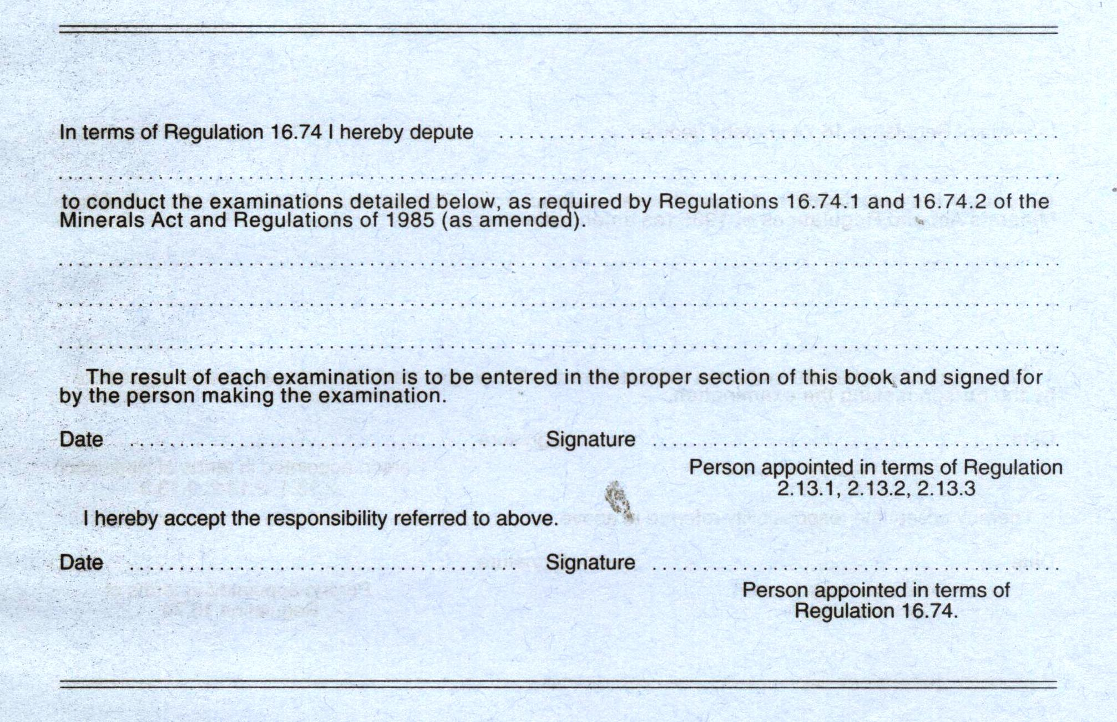

APPOINTMENT PAGE

CORE 04 Fig 01

Recording page in the Machinery Record Book:
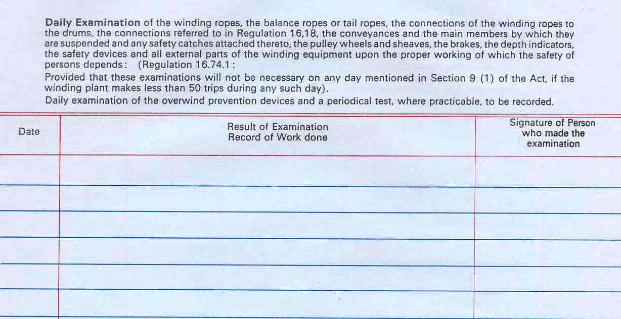
DAILY RECORD PAGE
CORE 04 Fig 02

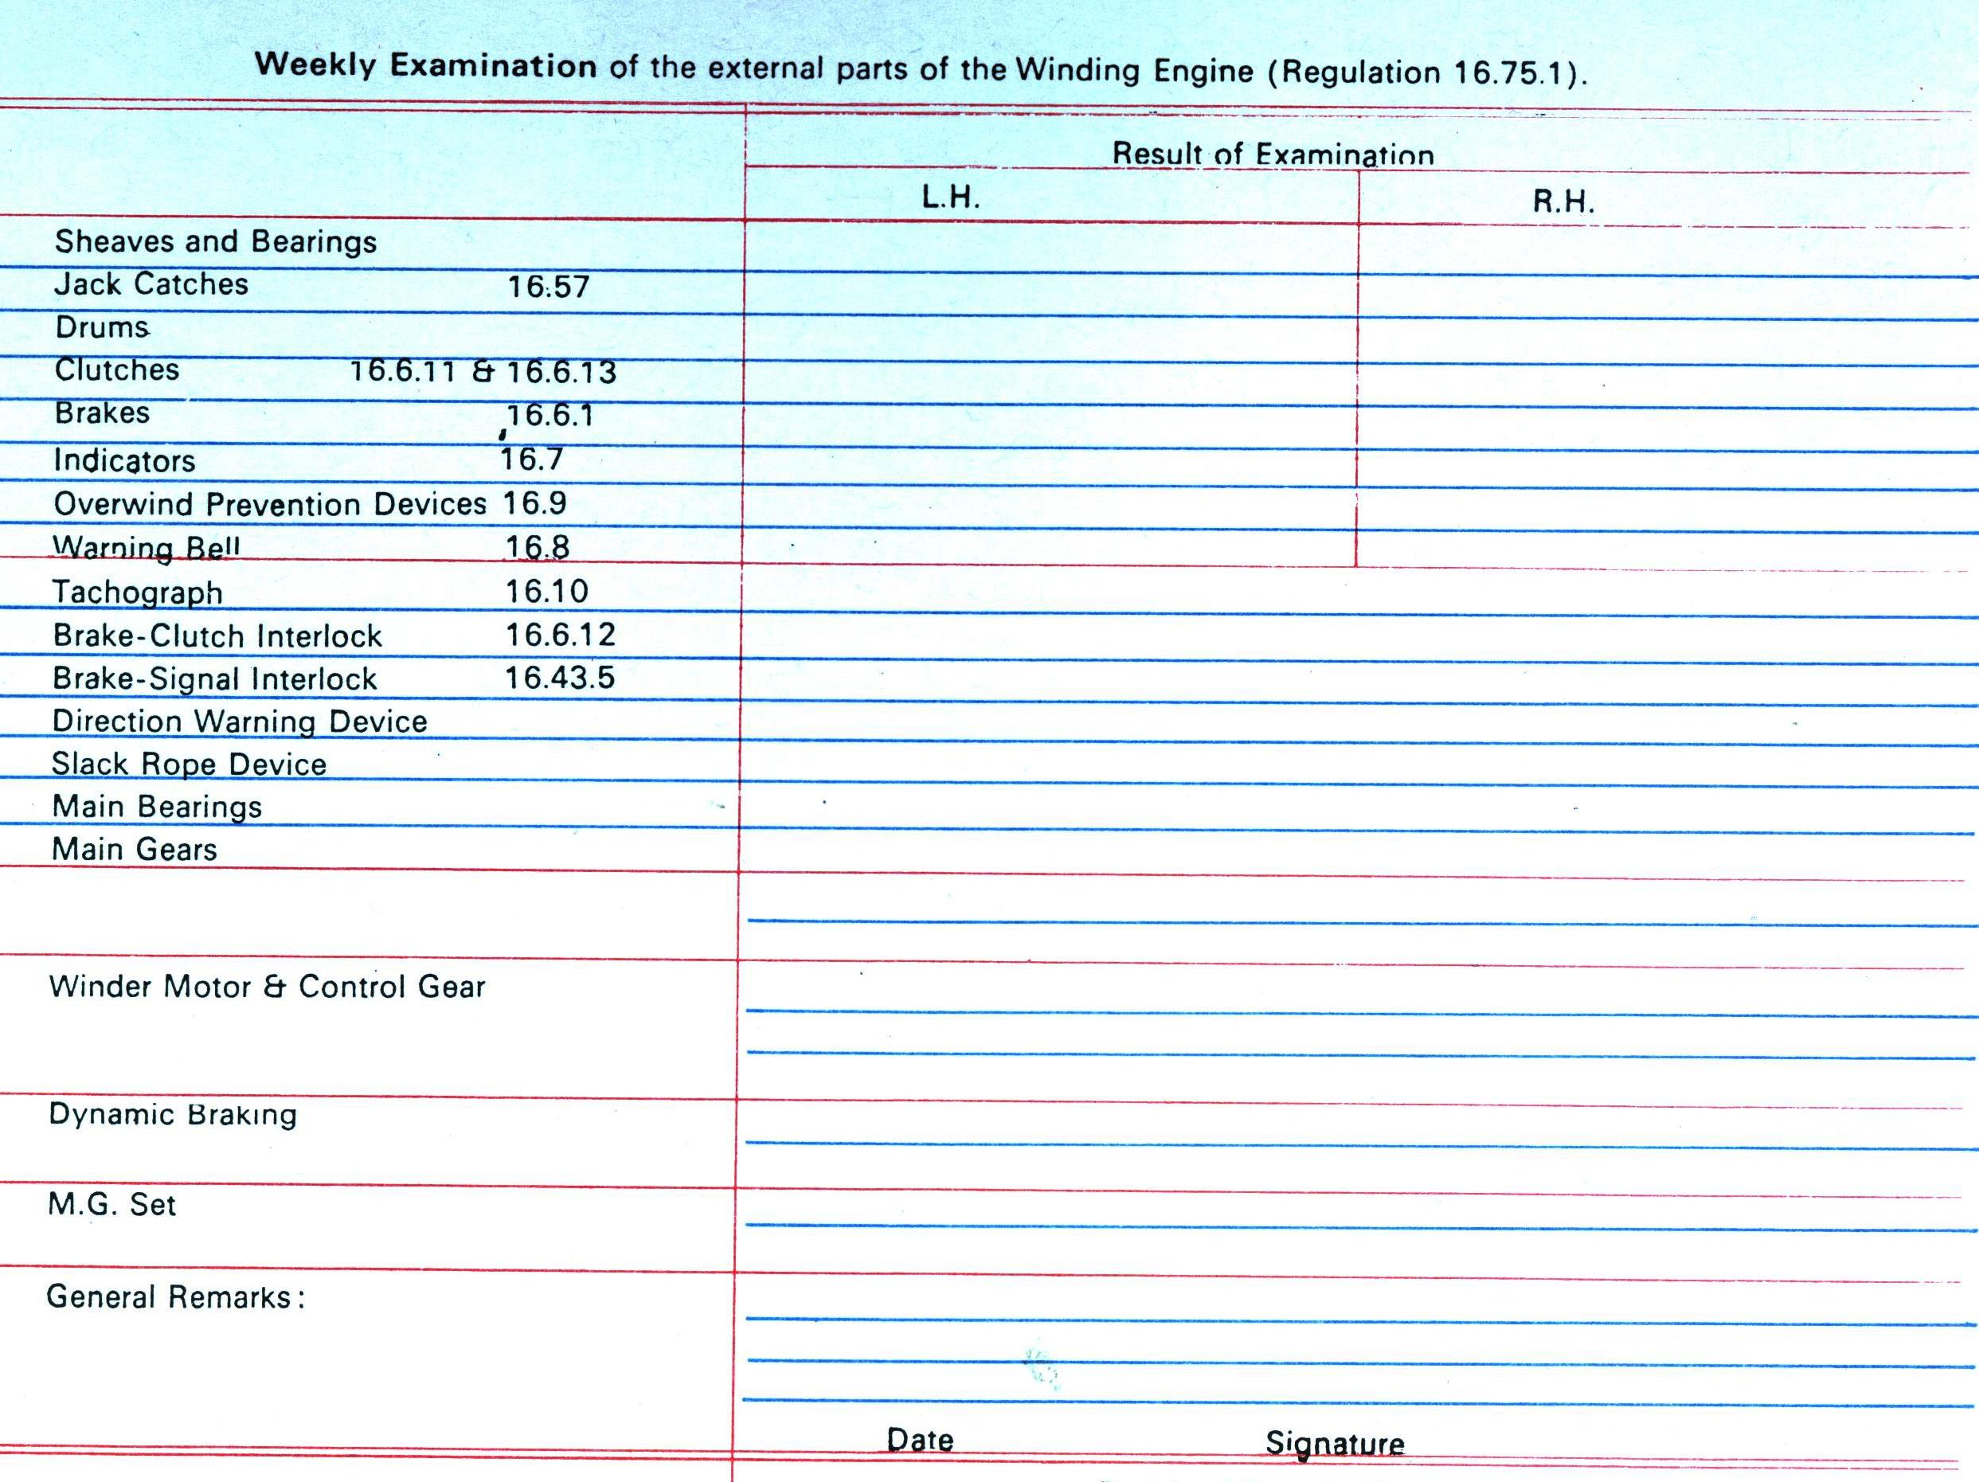
WEEKLY RECORD PAGE
CORE 04 Fig 03

You have completed this theory section of the Module. If you feel confident you are now at liberty to write the theory assessment. Make an appointment with the training department and go and write the test. Remember you need to obtain 100% to pass this Specific Outcome.
Good luck and don’t worry, the trainers are there to help you. Below is a guide line of what is required.
Assessment criteria | Evidence required  Expected answer or performance required
4.1 The requirements to complete the Machinery record book are explained | Did the candidate explain the requirements to complete the Machinery record book?  The explanation must include an understanding of the Machinery record book requirements.  Critical cross-field outcome of demonstrate an understanding of the world as a set of related systems by recognising that problem-solving contexts do not exist in isolation.  Being found competent in this AC demonstrates the ability of the candidate to understand the requirements of the Machinery record book.

ASSESSMENT CRITERION 5.1

Requirements to complete the small hoist record book

With the completing of the Small Record book exactly the same conditions apply as with the Machinery Record Book.

The only difference is that if you recall regulation 16.95, applicable to small winding engines, you will remember that you will also be required to be appointed in writing by your Sectional Engineer to carry out your duties according to regulation 16.74.1, but in this case you will only be required to examine the equipment once in each week and not on a daily basis. We will therefore not waste any more time on this aspect.

The small hoist record book is so similar to the Machinery Record Book that an example has not been shown here.

You have completed this theory section of the Module. If you feel confident you are now at liberty to write the theory assessment. Make an appointment with the training department and go and write the test. Remember you need to obtain 100% to pass this Specific Outcome.
Good luck and don’t worry, the trainers are there to help you. Below is a guide line of what is required.
Assessment criteria | Evidence required  Expected answer or performance required
5.1 The requirements to complete the Small Hoist record book are explained | Did the candidate explain the requirements to complete the Small Hoist record book?  The explanation must include an understanding of the Small Hoist record book requirements.  Critical cross-field outcome of demonstrate an understanding of the world as a set of related systems by recognising that problem-solving contexts do not exist in isolation.  Being found competent in this AC demonstrates the ability of the candidate to understand the requirements of the Small Hoist record book.

ASSESSMENT CRITERION 6.1

Requirements to complete the elevator record book

Having already dealt with the Mines and Works regulations applicable to Elevator Record Books previously, we will not go over them again, but only draw your attention to them.

As with the completion of Machinery Record Books, it is imperative that the same conditions apply to the recording and signing of Elevator Record Books, as here we also have to do with the safety of persons.

Recalling regulation 17.3.4, we will remember that the manager shall provide an Elevator Record Book for each elevator.

With elevators operational above surface we usually find that the manufacturers supply such a Record Book.

Elevators, where the cage operates below surface, fall in the same category as licensed winding engines, where instead of a special Elevator Record Book, the manager will supply a Machinery Record Book which will be termed the Elevator Record Book, and in both instances the requirements of the completion thereof will be similar.

As you are already familiar with the Machinery Record Book it is unnecessary to go over it again and will therefore discuss the special Elevator Record Book.

On the following 3 pages you will find example copies extracted from a Manufacturer's Elevator Record Book, being:

a) The appointments
b) The weekly examination report, and
c) Reports of any stoppages, breakdowns, accidents or repair details.

Ignore the regulations referred to on the sheets as they comply with the Factories, Machinery and Building Works Act, and are not applicable in our industry.

Complete the elevator record book

Example (a)
This sheet is where according to regulation 17.3.4 (a), you are required to be appointed in writing by the responsible Section Engineer.

Example (b)
This sheet is where you have to record the results of your weekly examination according to regulation 17.5.1 which, if you remember, stipulates that you shall examine carefully at least once in each week, in your case, the motor, all safety appliances, The brakes, gears, lubrication etc.

Example (c)
This sheet is where according to regulation 17.5.3, where as a result of your examination any weakness or defect is found whereby the safety of persons is or may be endangered, you shall record the defect, which must be reported to the responsible Section Engineer and the elevator stopped until such defect has been rectified.

Example (a):
ELEVATOR RECORD BOOK

I HEREBY DEPUTE _________________________________________________________

__________________________________________________________________________

__________________________________________________________________________
to conduct the examinations referred to in Regulation C118(1) of the Factories, Machinery and Building Works Act of 1941.

Date _____________________ __________________________
Owner or user

------------------------------------------------------------

I HEREBY DEPUTE _________________________________________________________

__________________________________________________________________________

__________________________________________________________________________
to conduct the examinations referred to in Regulation C118(1) of the Factories, Machinery and Building Works Act of 1941.

Date _____________________ __________________________
Owner or user

Example (b):

ELEVATOR RECORD BOOK
WEEKLY EXAMINATION OF THE GUIDES AND ROPES, THE ENGINE OR MOTOR, ALL DRUM, AND SHEAVES AND ALL SAFETY APPLIANCES: AS REQUIRED BY REGULATION No. C118
Date | Signature of person who made the examination | Report of the result of the examination

Example (c):
ELEVATOR RECORD BOOK
Date | Reports of any Stoppages, Breakdowns, Accidents or Repair Details

Example of a completed elevator record book

Electrical
Assuming during your examination you find that the arm of the door switch in the hatchway on the second landing has been broken off and the switch requires to be replaced. You have a spare switch in your workshop. Complete the examination report below.

Mechanical
Assuming during your examination you find that one of the brake shoes is badly worn and you have to replace it. You have spare brake shoes in the store. Complete the examination report below.

- Give a brief explanation of what you will do about the situation.
WEEKLY EXAMINATION OF THE GUIDES AND ROPES, THE ENGINE OR MOTOR, ALL DRUM, AND SHEAVES AND ALL SAFETY APPLIANCES: AS REQUIRED BY REGULATION No. C118
Date |  | Signature of person who made the examination |  | Report of the result of the examination
2007-07-31 |  | A.N. Other |  | 2nd DOOR LANDING SWITCH BROKEN
2008-02-06 | A.N. Other |  | Brake shoe badly worn out, need to be replaced

- After having done what you stipulated in (a) above, what will you record in the section below?
Date | Reports of any stoppages, breakdowns, accidents or repair details
2007-07-31 | 2nd door landing switch broken. Stopped elevator & installed new switch. Elevator checked and in order.
2008-02-06 | Brake shoe badly worn. Stopped elevator. Replaced brake shoe and re-adjusted brakes. Brakes tested and in good working order.

You have completed this theory section of the Module. If you feel confident you are now at liberty to write the theory assessment. Make an appointment with the training department and go and write the test. Remember you need to obtain 100% to pass this Specific Outcome.
Good luck and don’t worry, the trainers are there to help you. Below is a guide line of what is required.
Assessment criteria | Evidence required  Expected answer or performance required
6.1 The requirements to complete the Elevator record book are explained | Did the candidate explain the requirements to complete the Elevator record book?  The explanation must include an understanding of the difference between an elevator and a cage.  Critical cross-field outcome of demonstrate an understanding of the world as a set of related systems by recognising that problem-solving contexts do not exist in isolation.  Being found competent in this AC demonstrates the ability of the candidate to understand the requirements of the Elevator record book.

ASSESSMENT CRITERION 7.1 (Electrical Only)

Requirements to complete the substation record book

Having already dealt with the Preface to Substation Record books, let us recap on the sections applicable to the recording of the Substation Record Book.

- This book is to be used in accordance with the instructions given in the Preface. Under no circumstances is it to be removed, defaced or used for any other purpose whatsoever.

- The recording of all switching operations, or any material adjustment or modification of any kind as well as the recording of any maintenance to H.V. equipment and testing of protective devices, must be made in the log book and noted, dated and signed by the person responsible.

- This log book must remain in the substation at all times and should be initialled by the Surface Foreman Electrician a minimum of once every 30 days.

- Whenever a H.V. circuit breaker trips, the skilled person responsible for reclosing that circuit breaker should record in the log book what protective relays (if any) "flagged" and on what panel they are situated.

NOTE - On the standard 3 tier C.D.G. 36 relay used for over current and earth fault protection the flag that dropped should be identified by using the words "top", "middle" and "bottom" to prevent misunderstandings.)

- The section electrician should inspect monthly to confirm that the substation fire extinguishers are in place and the seals are not broken. The results of his inspection should be recorded in this log book and the Surface Foreman electrician should be notified immediately if found not to be in order.

PAGE FORMAT FOR ALL SUBSTATION RECORD BOOKS:

Date | Time | Operations performed HV equipment | Protection relays “Flagged” (if applicable) | Signature

Completing the Substation Record Book is a matter of reading the headings across the page.
- Operations Performed H.V. Equipment

In this section all operations performed on H.V. equipment should be recorded, such as for
- Switching operations
- Any material adjustments
- Modifications of any kind
- Maintenance to any H.T. equipment
- Testing of protective devices

- Protection Relays Flagged

NOTE - On the standard 3 tier C.D.G. 36 relay used for over current and earth fault protection the flag that dropped should be identified by using the words "top", "middle" and "bottom" to prevent misunderstandings.

- Date, Time and Signature
Most important is to record the date and time of your entry so as to give a clear indication as to what date and time the event took place, and sign your name to acknowledge your entry.

Example of a completed Substation record book (Electrical Only)

Assume on Sunday 5 August 2007 you have to do a yearly examination on the Auxiliary Transformer H.V.O.C.B. of a Rock Winder and change the oil as well.

You trip the circuit breaker by means of manually operating the “top” overcurrent relay of the CDG36 relay at 07h00. You isolate and rack out the OCB and rack in and reclose the OCB at 10h00 to check if all is in order.

The Surface Foreman Electrician does the necessary inspection tests and recording thereof in the log book.

Complete this copy of the log sheet showing what you have done.

Date | Time | Operations performed HV equipment | Protection relays “Flagged” (if applicable) | Signature
2007-08-05 | 07h00 | Isolate and rack out rock winder auxiliary transformer H.V. OCB for yearly exam.  Changed oil. | Manually operated “Top” O/C relay | A.N. Other
2007-08-05 | 10h00 | Rack in and recluse rock winder auxiliary transformer H.V. OCB. |  | A.N. Other

You have completed this theory section of the Module. If you feel confident you are now at liberty to write the theory assessment. Make an appointment with the training department and go and write the test. Remember you need to obtain 100% to pass this Specific Outcome.
Good luck and don’t worry, the trainers are there to help you. Below is a guide line of what is required.
Assessment criteria | Evidence required  Expected answer or performance required
7.1 The requirements to complete the Substation record book are explained | Did the candidate explain the requirements to complete a substation record book?  The explanation must include an understanding of the unique requirements of Substation records.  Critical cross-field outcome of demonstrate an understanding of the world as a set of related systems by recognising that problem-solving contexts do not exist in isolation.  Being found competent in this AC demonstrates the ability of the candidate to understand the requirements of the Substation record book.

ASSESSMENT CRITERION 8.1 (Mechanical Only)

Requirements to complete the humble hook record book

Having already dealt with the reasons for the humble hook Record book and the regulations, let us recap on the sections applicable to the recording of the information in the Record Book.
- In this case it shall by your responsibility to carefully examine at least once in each day, the humble hooks in your section of responsibility.
- The Humble hook is to be changed every 6 months and all the relevant information is to be recorded.
“At all times, when changing a Humble Hook in a compartment, its serial number, size and drawing number should be recorded”.

The following details must be recorded:
- Date when installed or removed.
- Location.
- Compartment.
- Total of months worked.

If the Humble Hook is removed and maintained the following should be recorded:
- Part Description.
- Reason for replacement.
- Date.
- The date of the NDT (Non destructive test)

Study the extract of the Log Sheet on the next page and become familiar with what is required of you.

Copy of the HUMBLE HOOK log sheet

HUMBLE HOOK DATA AND CASE HISTORY

HOOK NO: _______________SIZE: _______WINDER: __________DWG NO: ______________
DATELOCATIONTOTAL MONTHSDATE OF LAST N.D.TENGRS.
INTLSINSTALLEDREMOVEDSHAFTCOMPTWORKEDPROGRESSIVE
HOOK PARTS REPLACED SUMMARY
PART DESCRIPTIONREASON FOR REPLACEMENTDATEENG INTL

Example of a completed HUMBLE HOOK log sheet

Assume the Engineer of No 14 shaft purchased a new Humble Hook on the 04th April 2007. The Serial number is 4528 and the drawing number used is IMP2510 According to the drawing the size is 254. NDT took place of the humble hook on 14th April 2007. You installed it on the O/L of the Man conveyance on 14th May 2007. You removed it after routine rope change on 19 Nov 2007. The humble hook is completely dismantled, cleaned and ready for inspection. According to the Section Engineer the following parts are to be changed: Thimble pin, Standard Shackle, standard pin and lower link pin. The reason for replacement parts is that they are badly worn. The parts were installed on 28th Nov 2007.

HOOK PARTS REPLACED SUMMARY
PART DESCRIPTION | REASON FOR REPLACEMENT | DATE | ENG INIT
THIMBLE PIN | BADLY WORN | 28.11.2007
STANDARD SHACKLE | BADLY WORN | 28.11.2007
STANDARD PIN | BADLY WORN | 28.11.2007
LOWER LINK PIN | BADLY WORN | 28.11.2007
THIMBLE PIN | BADLY WORN | 28.11.2007

You have completed this theory section of the Module. If you feel confident you are now at liberty to write the theory assessment. Make an appointment with the training department and go and write the test. Remember you need to obtain 100% to pass this Specific Outcome.
Good luck and don’t worry, the trainers are there to help you. Below is a guide line of what is required.
Assessment criteria | Evidence required  Expected answer or performance required
8.1 The requirements to complete the Humble Hook record book are explained | Did the candidate explain the requirements to complete a Humble Hook record book?  The explanation must include an understanding of the unique requirements of Humble Hook records.  Critical cross-field outcome of demonstrate an understanding of the world as a set of related systems by recognising that problem-solving contexts do not exist in isolation.  Being found competent in this AC demonstrates the ability of the candidate to understand the requirements of the Humble Hook record book.

